**Universal features of outbreak duration for novel SARS-CoV-2 variants of concern**

Alex D. Washburne, Nathaniel Hupert, Nicole Kogan, William Hanage, Mauricio Santillana

**Abstract**

From an ongoing pandemic to endemic outbreak cycles, forecasting the epidemic trajectories of novel variants of concern is critical to understanding outbreak duration, burden, and medical demand. Here, we report a finding that SARS-CoV-2 outbreaks across US states and European countries exhibit strain-specific times from onset to peak in each strain’s outbreak cycles. The resulting comparative epidemiological data visualizations have allowed real-time tracking of outbreak progress towards peak medical demand.

**Body**

Pandemics are by definition novel occurrences, but their local manifestations can have common features nonetheless. Whether due to pathogen spillover from wildlife reservoirs (CITE: plowright etc.) or the endogenous evolution of a novel variant (CITE: H1N1; Davies et al Alpha.; Delta; Omicron), the introduction of a novel infectious agent occurs in one place at one time and slowly spreads. One approach to forecasting outbreak trajectories from novel pathogens is to collect individual-level data such as basic reproductive numbers, serial intervals, and case severity profiles, and input these parameters into population-level compartment models (CITE: IC report). Another, complimentary approach is to use data from early, well-documented outbreaks as reference points for defining key features of the epidemic curve, and then continually aggregate evidence of variant-specific outbreak features or explainable variation for use in comparative epidemiological nowcasting (CITE: timescale of burden?).

During the SARS-CoV-2 pandemic, global transmission has coincided with expansive viral evolution (CITE: NextStrain? Bedford, Holmes, others?), including several punctuated equilibria producing novel and heavily mutated variants of concern with distinct epidemiological properties (CITE: VOC review?). The continued evolution of novel variants has produced a disconnect between the realities of traditional model-based outbreak forecasting (slow), and the demand for assessment of the impact of novel variants on local outbreak duration, burden, and medical demand (fast). Here, using a novel method for conducting such rapid data analysis across the US and Europe, we report a common finding across outbreak cycles driven by two novel SARS-CoV-2 variants, Delta and Omicron.

The original, pandemic waves of 2020 and early 2021 were highly irregular, with many peaks and valleys driven by seasonal forcing and irregularly timed and variably effective interventions across regions. While there is some evidence that less-mitigated outbreaks converged to a common population fatality rate (CITE: Washburne et al.), the heterogeneous seasonality, containment, mitigation, and behavioral changes around the world led to few universal patterns of outbreak cycles one could use for comparative forecasts of epidemic trajectories caused by the original lineage of SARS-CoV-2.

The Delta variant then caused an outbreak in India in the first half of 2021 and later caused outbreaks in the UK, South Africa, and, in the United States, early outbreaks in the states of Missouri and Arkansas. These early archetypal outbreaks had similar durations, lasting roughly 75 days from the onset of case growth to their peaks (FIGURE, A). The highly similar transmission trajectories of early Delta outbreaks proved useful for predicting the transmission trajectories and duration of later outbreaks across the United States.

Omicron was first reported in South Africa in November, 2021 (CITE: Tulio & others?) with early evidence suggesting it could cause a rapid rate of growth of cases and a higher rate of reinfections (CITE: Pulliam et al.). The waning protection of vaccines against infection was documented prior to the arrival of Omicron (CITE: Qatar, Israel etc) and further evidence suggested that Omicron’s heavily mutated spike protein lowers binding the affinity of antibodies generated by current SARS-CoV-2 vaccines (CITE) and used in monoclonal antibody therapy (CITE). The complex and highly uncertain landscape of immunity against Omicron produced similar complexity and uncertainty about Omicron outbreak trajectories outside of South Africa.

We find that Omicron outbreaks across South African provinces are following a comparable pattern as earlier Delta outbreaks: South African provinces saw rapid case growth and equally rapid decelerations to peaks in approximately 30 days after the onset of Omicron-induced case growth (FIGURE). Early Omicron outbreaks in the United States are currently taking place in Hawaii, Florida, Puerto Rico, Washington D.C. and New York City, all of which are following transmission trajectories similar to earlier outbreaks in South African provinces. These early-identified universal features of Omicron outbreak trajectories and the previous efficacy of similar features in predicting Delta outbreak trajectories, produces a hypothesis that, absent highly effective containment or mitigation measures, Omicron outbreaks may peak roughly one month after they start.

The duration of outbreaks caused by novel pathogens can be a useful piece of information when strategizing mitigation policies and medical logistics. Another useful piece of information will be understanding case severity profiles to estimate upper bounds on medical demand. Early evidence suggests Omicron virions are better able to replicate in the bronchus than the lungs (CITE), may have a lower risk of hospitalization per-case (CITE) and may lead to shorter hospitalization times (CITE). US states throughout the Delta wave had similar transmission trajectories in their 75 day arc to peaks, yet case hospitalization rates were significantly lower in states with higher vaccination rates (FIGURE/GIF).

The dynamic interplay of immunity (both vaccine- and infection-induced) and strain-specific biological impact (e.g., related to predilection for upper vs. lower airway infection) will determine the magnitude and types of medical resources required for optimal patient management for Delta, Omicron and other new COVID-19 strains. Daily comparative epidemiological dashboards similar to those described here may allow managers to estimate upcoming medical demand in an ongoing, evidence-informed (rather than solely model-based) fashion. Such tools are not yet generally available but may be customized to local environments with use of regional, cross-national, or global comparators. To that end, the code used to make the figure in this manuscript is available on https://github.com/reptalex/outbreak_viz.

**Figure**

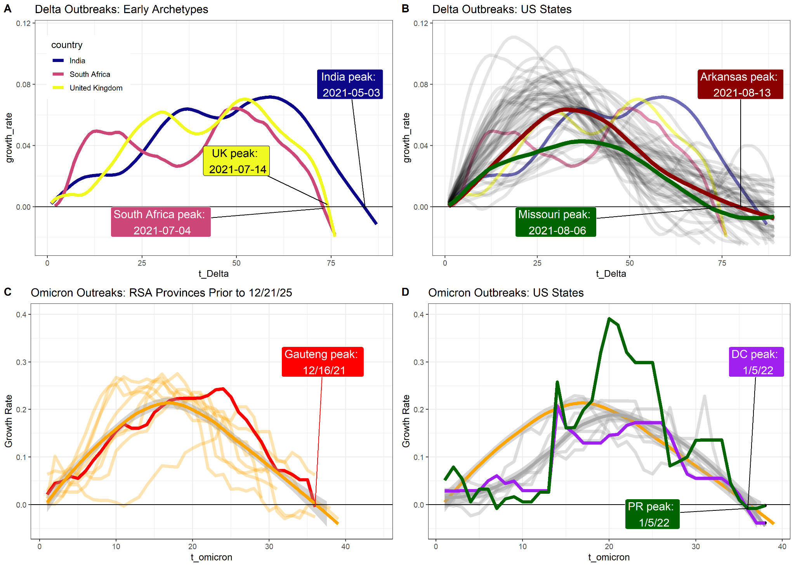

**Supplemental Information**

**Methods**

*Data source:* Data was downloaded daily using the R package COVID-19 (CITE).